NGINX upgrade version 1.10 to 1.16

1. Check the current version of nginx



1. Backup existing nginx 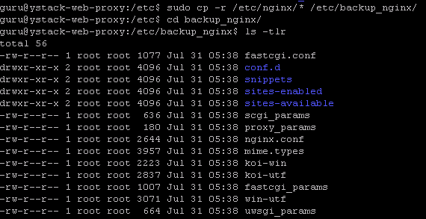
2. Install software-properties-common



1. Give blow commands:



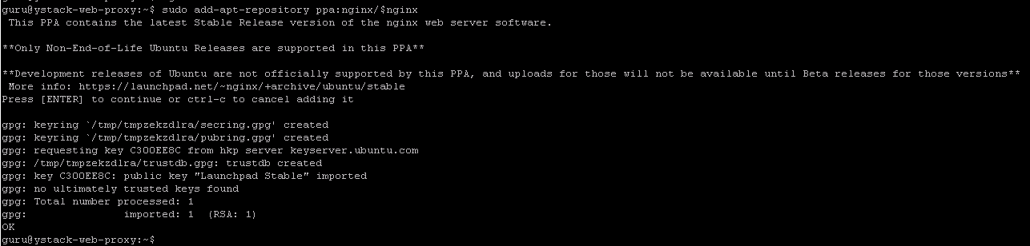





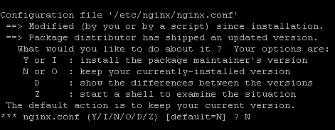

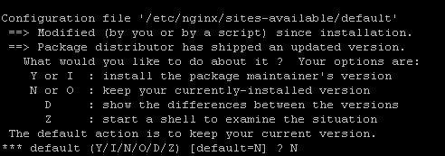

1. Add below to /etc/nginx/nginx.conf at the first line



1. Test nginx



1. restart



1. check version

